|  |  |  |
| --- | --- | --- |
| **شعار جامعة بنها الجديد** |  |  |
| **Benha University** |  | **Faculty of Computers & Artificial Intelligence** |

**Sign Language**

**Translator**

A senior project submitted in partial fulfillment of the requirements for the degree of Bachelor of Computers and Artificial Intelligence.

**Computer Science Departement,**

***Project Team***

1. Ahmed Mohamed Ahmed Esmail
2. Ahmed Mohamed Shaban Abas
3. Eslam Hamdy Ragab Abd Allah
4. Abdul-Rhman Rashwan Elsaid
5. Omar Ashraf Abd El-Qader Hegab
6. Ghaidaa Hisham Abd El-Monem Abd El-Aziz
7. Sherif Alaa Abd El-Monem Mohamed
8. Mustafa Khaled Abdo Mohamed

***Under Supervision of***

**Dr. Rasha Orban**

**Eng: Doaa Mohamed**

DECLARATION

We hereby certify that this material, which we now submit for assessment on the program of study leading to the award of Bachelor of Computers and Artificial Intelligence in *(Bachelor's)* is entirely our own work, that we have exercised reasonable care to ensure that the work is original, and does not to the best of our knowledge breach any law of copyright, and has not been taken from the work of others save and to the extent that such work has been cited and acknowledged within the text of our work.

**Signed:** _____________________________

**Date:** Wednesday, 12 02 2024.

Table of Contents

1. Introduction and Background 5

1.1 Introduction 5

1.2 Problem Definition: 6

1.2.1 Description of the Problem: 6

1.2.2 Scope of the Problem: 6

1.2.3 Objectives and Goals: 6

1.2.4 Constraints and Limitations: 6

1.2.5 Stakeholders and Users: 6

1.2.6 Functional Requirements: 7

1.2.7 Non-functional Requirements: 7

1.2.8 Assumptions and Risks: 7

1.2.9 Success Criteria: 7

1.3 Problem Solution: 8

1.3.1 Proposed Solution: 8

1.3.2 Technical Approach: 8

1.3.3 System Architecture: 8

1.3.4 User Interface Design: 8

1.3.5 Testing and Validation: 8

1.3.6 Accessibility and Inclusivity: 9

1.3.7 Deployment and Scalability: 9

1.3.8 Monitoring and Maintenance: 9

1.3.9 Expected Outcomes: 9

1.4 Scope: 9

1.4.1 Objective: 9

1.4.2 Location: 9

1.4.3 Budget: 9

1.4.4 Milestones: 10

1.4.5 Projects Parts/Components: 10

1.4.6 Project Description: 10

1.4.7 Type of Works (BOQ - Bill of Quantities): 10

1.4.8 Roles and Responsibilities for Different Parties: 10

2. System Design 11

2.1 Use Case Diagram 11

2.1.1 User Roles: 11

2.1.2 Use Cases: 11

2.2 Activity Diagrams 18

2.2.1 Registration: 18

2.2.2 Login 19

2.2.3 Reset Password: 20

2.2.4 Translate from sign to text: 21

2.2.5 Translate from text to sign: 22

2.2.6 Education: 23

2.2.7 Add Course: 24

2.2.8 Remove Courses 25

2.2.9 Modify Courses 26

2.2.10 Chatbot 27

2.2.11 Progress in Course 28

2.2.12 view courses 29

2.2.13 Manage Account: 30

2.3 Class Diagram: 31

[2.4 Sequence Diagram: 32](https://fcibuedu-my.sharepoint.com/personal/ahmed20491_fci_bu_edu_eg/Documents/Sign%20language%20translator%20project.docx#_Toc157388203)

2.5 Data Flow Diagrams 39

2.5.1 Context Diagram – Level 0 39

2.5.2 Level 1 40

2.6 ER Diagram 41

# Introduction and Background

## Introduction

The Sign Language Translator project represents a significant step forward in addressing the communication challenges faced by the deaf community. By leveraging cutting-edge artificial intelligence technology, this initiative aims to provide a practical and user-friendly solution for seamless communication between individuals with hearing impairments and the broader society.

One key aspect of this project is its use of an AI-driven model, which excels in analyzing textual inputs with precision and translating them into sign language accurately and efficiently. This feature ensures that the communication is not only accessible but also reliable for the users.

Moreover, the integration of the camera function into the application opens up new possibilities by allowing the conversion of sign language into text. This innovative approach facilitates interaction with the surrounding environment, enabling more dynamic and versatile communication for individuals with hearing impairments.

The user interface is another crucial element of the Sign Language Translator project. Designed to be simple and intuitive, it ensures that users can navigate the application with ease. The customizable settings further enhance the user experience, catering to individual needs and preferences.

By focusing on enhancing communication for the deaf community, this project contributes to fostering a sense of inclusivity and improving the overall quality of daily life for individuals with hearing impairments. The goal is to make communication a universal right, transcending barriers and creating a more connected and inclusive world.

This transformative journey invites individuals to join the effort, recognizing the importance of making communication accessible to everyone and supporting the creation of a more inclusive society. Through collaborative efforts, the Sign Language Translator project aims to create positive change and make strides towards a world where effective communication is indeed a universal right.

## Problem Definition:

### Description of the Problem:

The project aims to develop a Sign Language Translation that facilitates communication between individuals who use sign language and those who do not. The goal is to bridge the communication gap and provide a seamless means for sign language users to interact with the broader community.

### Scope of the Problem:

The scope includes the development of a real-time sign language translation system that can interpret and convert sign language gestures into spoken or written language.

### Objectives and Goals:

* Enable effective communication for deaf or hard of hearing individuals in various settings, including educational institutions, workplaces, and social environments.
* Develop a user-friendly interface that accommodates both sign language users and those unfamiliar with sign language.
* Provide accurate and timely translation of sign language gestures to spoken or written language.

### Constraints and Limitations:

* The system must operate in real-time to ensure effective and natural communication.
* Consideration of different dialects and variations within the chosen sign language.
* Accessibility requirements, ensuring the system is usable by individuals with varying levels of technological proficiency.

### Stakeholders and Users:

* Primary stakeholders include those deaf or hard of hearing.
* Secondary stakeholders include educators, employers, and community members interested in fostering inclusive communication.
* Developers and Project Management Team: stakeholders responsible for designing, developing, and implementing the communication accessibility project. Their involvement is crucial for the success of the initiative.
* Potential Investors or Funding Sources: Stakeholders who provide financial support for the project. Their involvement is essential to ensure the availability of resources needed for development, implementation, and sustainability.
* User Experience and Accessibility Experts: Stakeholders who bring expertise in user experience and accessibility. Their role is important in advising and guiding the development team to create solutions that meet the specific needs of the deaf and hard-of-hearing community.

### Functional Requirements:

* Capture and interpret sign language gestures through computer vision or similar technology.
* Translate interpreted gestures into spoken language or text.
* Provide a user interface that is intuitive for both sign language users and non-sign language users.

### Non-functional Requirements:

* Ensure high accuracy in gesture recognition to minimize misinterpretations.
* Minimize latency to achieve real-time communication.
* Implement security measures to protect user privacy and data.

### Assumptions and Risks:

* Assumption: Adequate training data for the chosen sign language will be available.
* Risk: Variability in individual signing styles may pose challenges for accurate interpretation.

### Success Criteria:

Positive feedback from end-users regarding the system's usability and effectiveness.

## Problem Solution:

### Proposed Solution:

* Develop a Sign Language Translation that employs a combination of computer vision, machine learning, and natural language processing techniques to accurately interpret sign language gestures in real-time. The system will then translate these gestures into spoken language or text, providing a seamless means of communication for individuals who use sign language.

### Technical Approach:

* Computer Vision: Utilize computer vision algorithms to capture and analyze sign language gestures through video input.
* Machine Learning: Implement machine learning models trained on diverse datasets to enhance the system's accuracy and adaptability to individual signing styles.
* Natural Language Processing: Employ natural language processing algorithms to convert interpreted gestures into spoken language or written text.

### System Architecture:

* The system will consist of a camera to capture sign language gestures.
* Computer vision algorithms will preprocess and interpret the gestures.
* Machine learning models will refine the interpretation based on individual user patterns.
* The translated output will be presented through a user-friendly interface, including spoken language output and/or on-screen text.

### User Interface Design:

* Develop an intuitive interface that accommodates both sign language users and non-sign language users.
* Provide options for customization, allowing users to adapt the system to their individual preferences.

### Testing and Validation:

* Conduct rigorous testing using diverse datasets to train and evaluate the machine learning models.
* Perform user testing with individuals who use sign language to validate the system's accuracy and usability.
* Iterate on the system based on user feedback to continuously improve performance.

### Accessibility and Inclusivity:

* Ensure the system is accessible to individuals with varying levels of technological proficiency.
* Implement features that consider different dialects and variations within the chosen sign language.
* Prioritize user privacy and data security in the design and implementation.

### Deployment and Scalability:

* Develop the system with scalability in mind to accommodate potential expansion to other sign languages.
* Plan for easy deployment in diverse settings, including educational institutions, workplaces, and community spaces.

### Monitoring and Maintenance:

* Implement monitoring tools to track system performance and user feedback.
* Establish a maintenance plan to address issues, update models, and incorporate improvements over time.

### Expected Outcomes:

* Positive feedback from end-users regarding the system's usability and effectiveness.
* Increased accessibility and inclusivity in communication for individuals who use sign language

## Scope:

### **Objective**:

* Develop an advanced Sign Language Translator application that enables seamless communication between individuals with hearing impairments and the broader community.
* Provide a user-friendly interface for text-to-sign language and sign language-to-text translations, supporting inclusivity and accessibility.

### Location:

* The project will be designed as a mobile application and a web page, ensuring accessibility across various devices and platforms.

### Budget:

* Allocate resources for the development, testing, and implementation phases.
* Account for potential expenses related to AI model development, server hosting, and platform compatibility.

### Milestones:

* Define key milestones, including the completion of AI model development, implementation of translation features, user interface design, testing phases, and the launch of the application.

### Projects Parts/Components:

* Text-to-Sign Language Translation Module.
* Sign Language-to-Text Translation Module.
* User Interface Design.
* Camera Integration Module.
* Cross-Platform Compatibility Module.
* Security and Privacy Features.
* Testing and Quality Assurance.

### Project Description:

* The project aims to create a state-of-the-art Sign Language Translator application, leveraging AI for accurate translation between text and sign language. The user-friendly interface and camera integration facilitate dynamic and inclusive communication.

### Type of Works (BOQ - Bill of Quantities):

* Specify the quantity and types of resources needed for AI model development, server hosting, software development, and testing.

### Roles and Responsibilities for Different Parties:

* Developers: Responsible for AI model development, software coding, and application testing.
* Project Management Team: Oversee project timelines, milestones, and resource allocation.
* User Experience Experts: Ensure the design meets accessibility standards and provides an optimal user experience.
* Investors/Funding Sources: Provide financial support for the project.
* Testing Team: Conduct thorough testing to identify and resolve any issues before the application launch.

By addressing these components within the project scope, you establish a comprehensive framework that guides the development and implementation of the Sign Language Translator application.

# System Design

## Use Case Diagram

The Sign Language Translator Software accommodates four distinct user roles Admin, Guest (Gest), Normal User, and Deaf User. This platform encompasses 15 essential functions to enhance communication between sign language speakers and non-sign language speakers. Below is an elaboration of the primary components and functions captured in the use case diagram:

### User Roles:

* + **Admin:** System administrator responsible for managing courses and user accounts.
  + **Guest:** Unregistered users exploring the system without authentication.
  + **Normal User:** Authenticated users interested in learning sign language and utilizing translation features.
  + **Deaf User:** Users who are deaf and rely on sign language for communication.

### Use Cases:

* + **Login:** Allows users to securely log into their accounts.
  + **Registration:** Enables new users to create accounts within the system.
  + **Reset Password:** Provides a mechanism for users to reset their passwords securely.
  + **Translate Sign to Text:** Converts sign language gestures into textual information for non- sign language speakers.
  + **Translate Text to Sign:** Transforms textual input into sign language gestures for sign language speakers.
  + **Education:** Offers educational resources and tutorials for users to learn sign language.
  + **Add Course:** Allows administrators to add new sign language courses to the system.
  + **Edit Course:** Permits administrators to modify existing course content.
  + **Remove Course:** Enables administrators to delete courses from the system.
  + **Chat bot:** provides a chat bot that has predefined questions and answers and if the user’s question isn’t answered the bot will forward user to an admin’s email.
  + **View Progress in Course:** Allows users to track their progress within enrolled courses.
  + **View Courses:** Displays a list of available sign language courses.
  + **View User Information:** Provides users with access to their account information.
  + 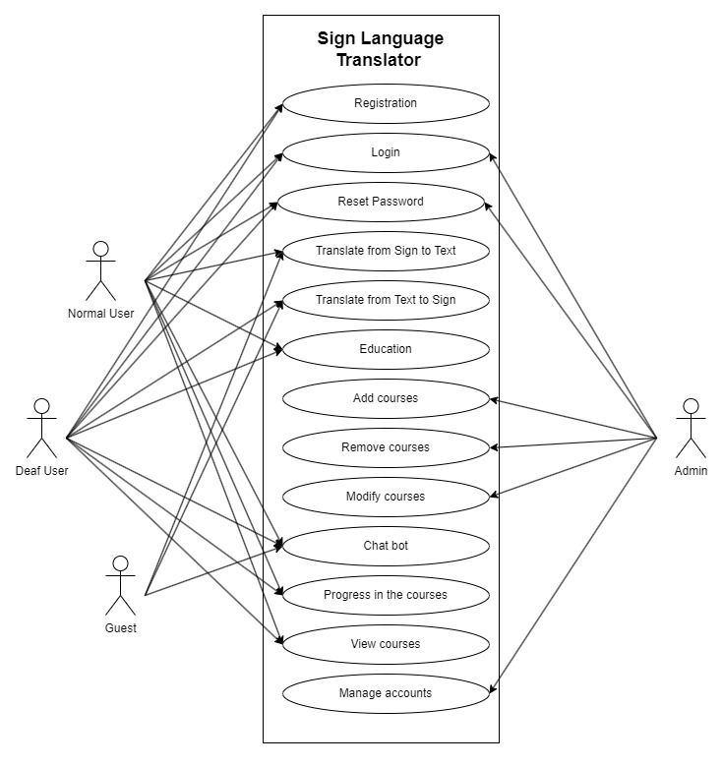**Delete Account:** Allows users to permanently delete their accounts.

|  |  |
| --- | --- |
| Use Case ID | 1 |
| Use Case name | Registration |
| Actors | Normal user, Deaf user, Guest. |
| Preconditions | None. |
| Normal Flow | 1. User clicks on Sing Up button. 2. User fills in his/her information. 3. Users receive confirmation E-mail. 4. The system displays the Sign Translation page. |
| Post conditions | 1. Open Home page 2. The user’s details are stored in the database. |
| Alternative Flow | The information already exists. |

|  |  |
| --- | --- |
| Use Case ID | 2 |
| Use Case name | Login |
| Actors | Admin, Normal User, Deaf User. |
| Preconditions | Admin, Normal User and Deaf User need to complete the registration process. |
| Normal Flow | 1. Insert Username. 2. Insert Password. 3. Login. |
| Post conditions | Login Successfully. |
| Alternative Flow | * Insert the Incorrect Username. * Insert the Incorrect Password. |

|  |  |
| --- | --- |
| Use Case ID | 3 |
| Use Case name | Reset Password |
| Actors | Admin, Normal User, Deaf User. |
| Preconditions | Admin, Normal User and Deaf User Must be Registered. |
| Normal Flow | 1. Insert username or email. 2. A reset password link will be sent to user email if it is correct and exists in database. 3. Enter a new password. 4. Confirm password. |
| Post conditions | Password has been Reset. |
| Alternative Flow | * Insert Incorrect Email Address or username. * Insert the Same Old Password. |

|  |  |
| --- | --- |
| Use Case ID | 4 |
| Use Case name | Translate From Sign to Text |
| Actors | Normal User, Guest |
| Preconditions | Normal User or Guest must enter the sign which he wants to translate to text |
| Normal Flow | 1. Enter the sign you want to translate to text 2. Return text |
| Post conditions | Translate from sign to text successful |

|  |  |
| --- | --- |
| Use Case ID | 5 |
| Use Case name | Translate From Text to Sign |
| Actors | Deaf User, Guest |
| Preconditions | The Deaf User or the Guest must enter the text which he wants to translate to sign |
| Normal Flow | 1. Enter the text you want to translate to sign. 2. Return sign |
| Post conditions | Translate from text to sign successful |
| Alternative Flow | * did not enter any text or enter a not understood text |

|  |  |
| --- | --- |
| Use Case ID | 6 |
| Use Case name | Education |
| Actors | Normal user, Deaf user |
| Preconditions | Users must log in first to access the educational platform.  Course content is available for the selected course. |
| Normal Flow | 1. User selects a course. 2. User views course content and interacts with it. |
| Post conditions | The user successfully accesses and interacts with the course content. |
| Alternative Flow | In case of technical issues, the user is redirected to a support page. |

|  |  |
| --- | --- |
| Use Case ID | 7 |
| Use Case name | Add Course |
| Actors | Admin |
| Preconditions | Admin must log in first to access the course management system. |
| Normal Flow | 1. Admin navigates to the "Add Course" section. 2. Admin provides course details. 3. Admin click on “Add Course” button. 4. The system verifies and stores the course information. |
| Post conditions | The new course has been successfully added to the system. |
| Alternative Flow | If there are any validation errors (missing information or duplicate course name), the system prompts the admin to correct the errors and resubmit. |

|  |  |
| --- | --- |
| Use Case ID | 8 |
| Use Case name | Remove courses |
| Actors | Admin |
| Preconditions | The admin must enter the course code to remove it |
| Normal Flow | 1. Admin login. 2. Admin click on delete course tap 3. Confirm the admin identity 4. Admin enter course code 5. Admin click on delete button |
| Post conditions | Course deletes successful |
| Alternative Flow | have not entered the course code or entered the course code incorrectly |

|  |  |
| --- | --- |
| Use Case ID | 9 |
| Use Case name | Modify courses |
| Actors | Admin |
| Preconditions | The admin must enter the course code to modify it |
| Normal Flow | 1. Admin login. 2. Admin click on modify course tap. 3. Confirm the admin identity. 4. Admin enter course code. 5. Admin click on modify button. |
| Post conditions | Courses modify successful |
| Alternative Flow | have not entered the course code or entered the course code incorrectly |

|  |  |
| --- | --- |
| Use Case ID | 10 |
| Use Case name | Chat Bot |
| Actors | Normal User, Deaf User, Guest. |
| Preconditions | none |
| Normal Flow | 1. Go to the chat bot section. 2. Choose one of the available question. 3. The bot should return the answer. 4. If the user want’s more help the bot will provide the user with admin email to ask him directly |
| Post conditions | * User gets answer for his question. * User gets admin email to contact him directly |
| Alternative Flow | * Faild to access chat bot |

|  |  |
| --- | --- |
| Use Case ID | 11 |
| Use Case name | progress in courses |
| Actors | Normal user, deaf user |
| Preconditions | View courses and learn through them in the system |
| Normal Flow | 1. view courses 2. learning 3. show progress in courses |
| Post conditions | show progress in courses |
| Alternative Flow | The user hasn’t Enrolled in any courses yet |

|  |  |
| --- | --- |
| Use Case ID | 12 |
| Use Case name | View courses |
| Actors | Normal user, deaf user |
| Preconditions | Normal User and Deaf User Must do Registration and log in successfully.  Admin must add course.  Normal User, Deaf User must progress in courses |
| Normal Flow | 1. User login 2. view courses |
| Post conditions | Access the courses through which we Learn |
| Alternative Flow | no courses exist |

|  |  |
| --- | --- |
| Use Case ID | 13 |
| Use Case name | Manage Accounts |
| Actors | Admin |
| Preconditions | User Must be Logged in As Admin |
| Normal Flow | 1. Admin login. 2. Click on the Manage Accounts button. 3. Search for the profile he wants to view. 4. Display User profile 5. - If the admin wants to edit account, should click on edit account   - or he can delete account by pressing delete account  - to delete or edit account the admin must confirm his password |
| Post conditions | View, edit or delete user Account |
| Alternative Flow | * The user does not exist. * Wrong password |

## Activity Diagrams

The Activity Diagram explains the operations that are carried out on each process, and I see the validation, The powers, and how will the system work, In the case of success, one thing is done, and in case of failure, another thing is done.

* + 1. A diagram of a computer program

       Description automatically generatedRegistration:

Users are required to provide relevant information such as personal details and contact information.

Once the necessary information is entered,

users will typically need to create a username and password, followed by verification steps to ensure the accuracy of the provided details.

After successfully completing these steps,

users gain access to the platform or system with their unique credentials.

* + 1. Login**:**

The login process typically follows the registration process and involves users accessing the Application or Website using their previously created credentials.

### Reset Password:

The activity diagram visually represents the flow of activities, decisions, and interactions between the user and the system during the password reset process.

It starts with the user input his username or email, if the email that user entered is correct and exists in database,

A reset password Link will be sent for this email.

After this user enter a new password, confirm it and if it’s valid, the password will be reset successfully.

### Translate from sign to text:

As a user and he wants to translate from sign to text first he opens the translation page and begin to translate

* if as usual he does not enter any sign or a not understood one nothing will be translated so he must enter an understood sign to translate successfully

### Translate from text to sign:

As a user and he wants to translate from text to sign first he opens the translation page and begin to translate

* if as usual if he did not enter any text or a entered a not understood text nothing will be translated so he must enter an understood text to translate successfully

### Education:

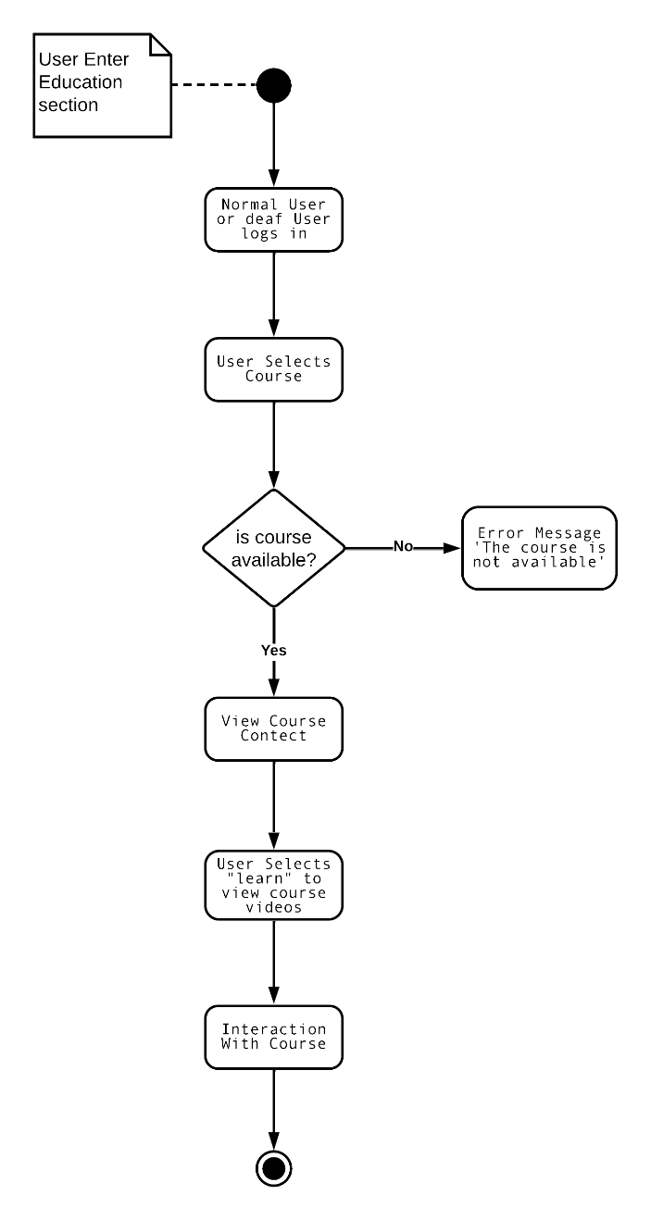

As the user explores the education section, he begins by logging in, the user first must login to view the course and start to learn.

* After that, he selects a course he is interested in. The system then checks if the chosen course is available.
* If it is, the user moves forward.
* if not, the user will be redirected to a support page for assistance. Once the course is confirmed available, the user gets access to its content.
* He can then interact with the material, participating in discussions and completing assignments, making the learning experience engaging and inclusive.

### Add Course:

The course addition process starts with the admin logging into the course management system. The admin then goes to the section where courses can be added and provides necessary details like the course name and description. Clicking on "Add Course" saves this information.

The system checks for errors.

* If there are any, it asks the admin to fix them.
* If everything is error-free, the system stores the course details in the database.
* The activity concludes with a confirmation message, indicating that the course has been successfully added to the system.

### Remove Courses

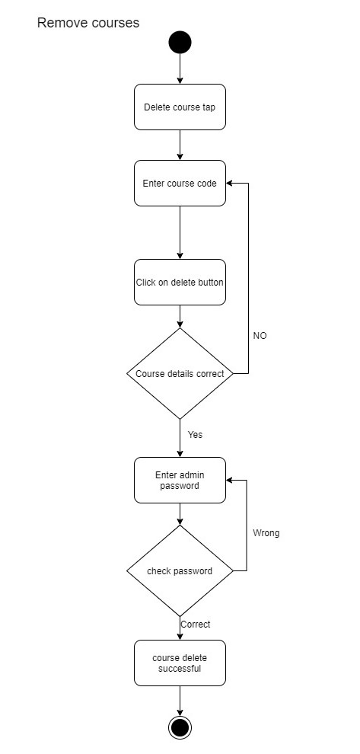

The course Remove process starts with the admin logging into the course management system. The admin then goes to the section where courses can be removed and provides necessary details like the course id.

* Clicking on "Delete Course" removes this information.
* The system checks for errors. If there are any, it asks the admin to fix them.
* If everything is error-free, the system removes the course from the database.
* The activity concludes with a confirmation message, indicating that the course has been removed.

### **Modify Courses**

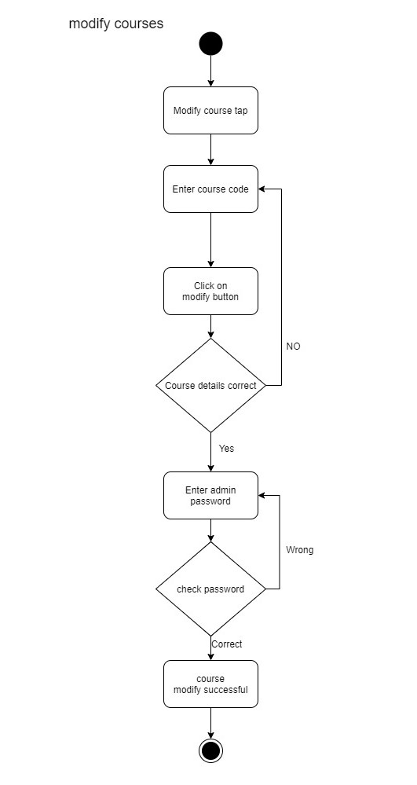

The course modify process starts with the admin logging into the course management system. The admin then goes to the section where courses can be modified and provides necessary details like the course id, name and description.

* Clicking on "Modify Course" modifies course information.
* The system checks for errors. If there are any, it asks the admin to fix them.
* If everything is error-free, the system modifies the course in the database.
* The activity concludes with a confirmation message, indicating that the course has been modified.

### Chatbot

1. **User Interaction:**

The chatbot interacts with users through a chat interface embedded on the website. Users can type messages or questions, and the chatbot responds with relevant information or actions.

1. **Task Assistance:**

This chatbot are designed to assist users in completing specific tasks, such as answer about new courses or how to use the website.

* If the user needs more info, he can go to the admin email and ask him everything he wants.
* This chatbot are designed to assist users in completing specific tasks, such as answer about new courses or how to use the website.

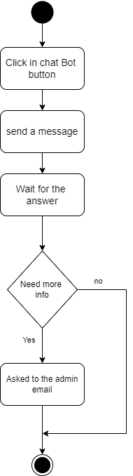

### Progress in Course

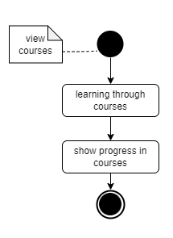

Normal and deaf users can see their progress in learning the courses.

progress in courses means how much user has learned from the entire course.

In the beginning, you must show the available courses.

then choose the appropriate course for you so that you can learn from it and follow in its footsteps.

By continuing your learning, you can see the extent of your progress in the course and how much you have accomplished from it.

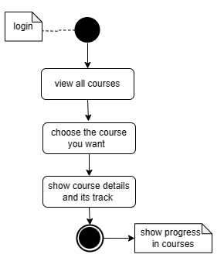

### view courses

One of the goals of the project is to teach deaf and normal users sign language, which is done through courses. so, the user must view these courses. The user logs into his account

, Then he chooses view courses, through which all the courses in the system that are available to the user are displayed.

, The user chooses the course he wants.

, The details of this course and the educational path it will follow are displayed.

### Manage Account:

The Admin Can Manage User Accounts such as viewing, editing or deleting account.

The admin can view user information like:

* Name
* Username
* Profile photo
* Gender
* And Enrolled courses

To view the information The admin must search for the user using his username.

If the username exists, the system will show the user information.

If Ther is no user with This username the system will show a message That The user doesn’t Exist and Back again to Search page.

After viewing account admin can edit or delete account

To delete or edit Any user Account The admin must Enter his password to confirm deletion:

* If the password isn’t correct the system will return to user profile Again
* If the password is correct the user will be deleted permanently

Deleting user Account is permanent and will delete any data related to the user like enrolled courses, progress in courses, profile photo, etc...

**2.2.14 Manage Account**

## Class Diagram:

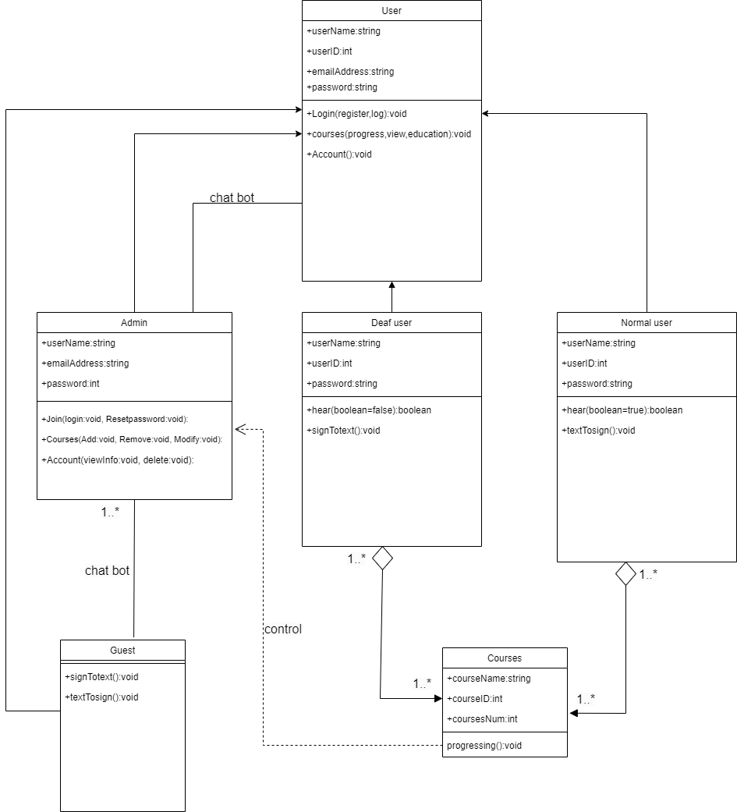

## 2.4 Sequence Diagram:

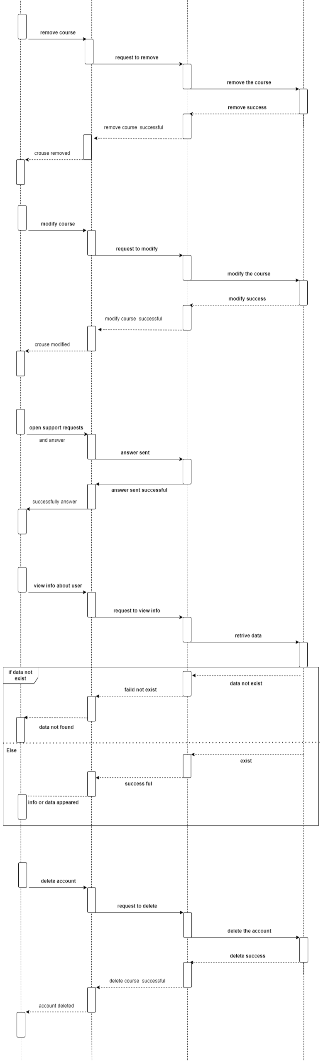

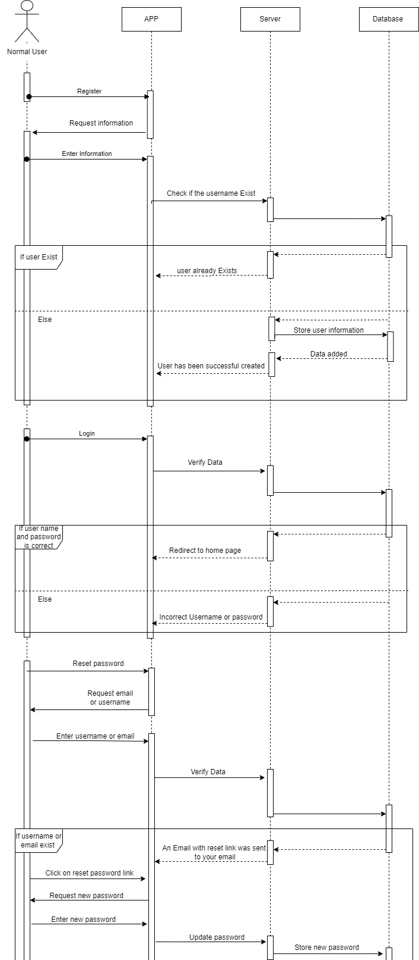

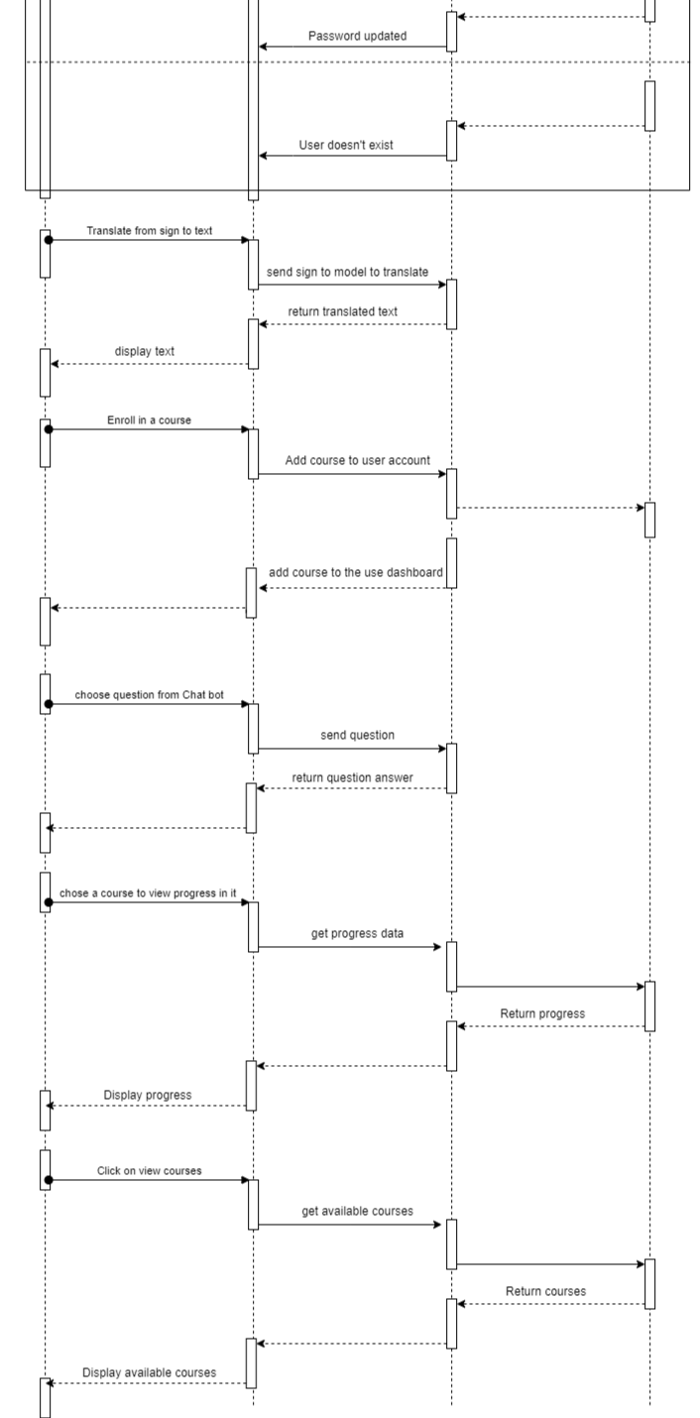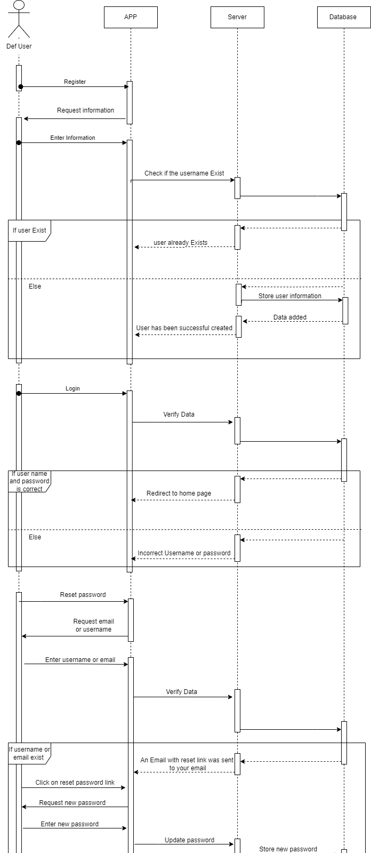

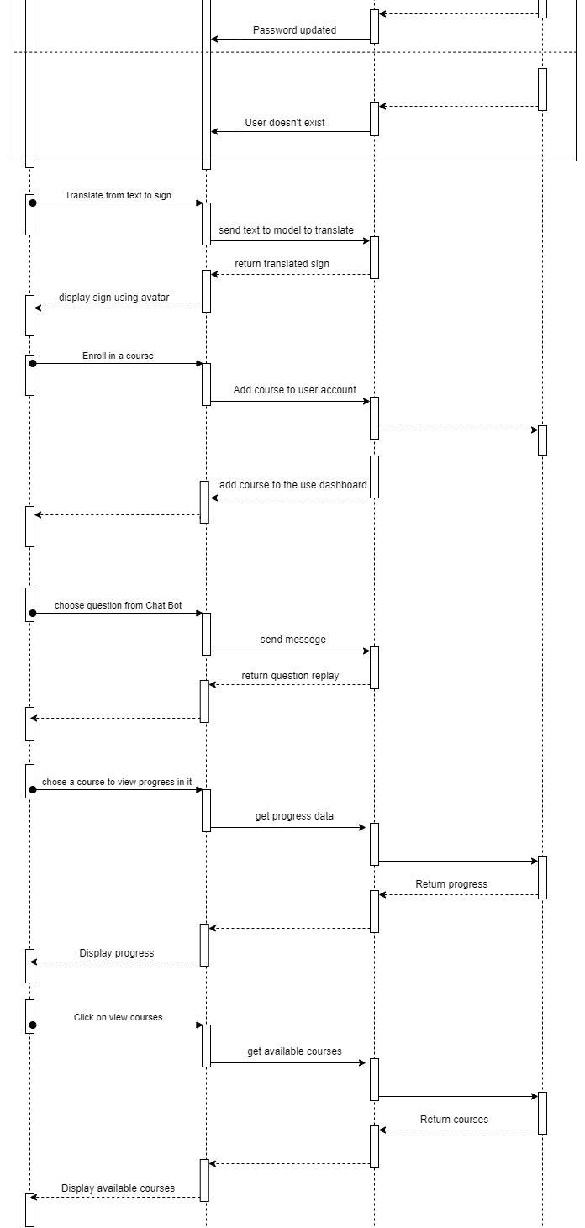

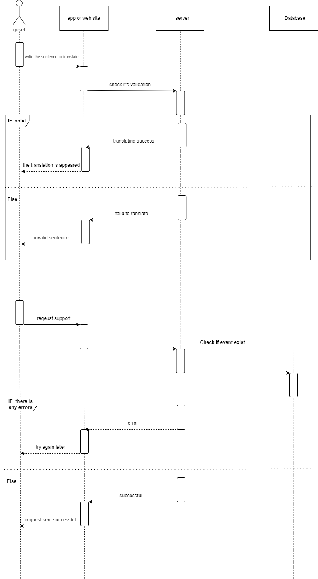

## Data Flow Diagrams

The Data Flow Diagrams are used to graphically represent the flow of data in a business information system. DFD describes the processes that are involved in a system to transfer data from the input to the file storage and report generation.

### Context Diagram – Level 0

This Context Diagram in **Error! Reference source not found.**…., shows The most prominent users are Normal User , Deaf User , Guest and Admin, and Normal User , Deaf User , Guest can use the Application or the Website to create a new account if they don't have one or log in directly if they have, then after the system verifies the data that they enter and make sure that it's valid data they can move to the home screen and access to the complete processes.

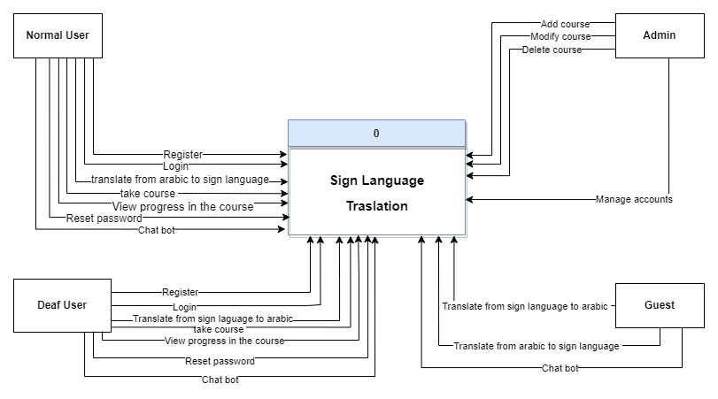

### Level 1

This Level in Figure …, shows in detail more than Context Diagram.

## ER Diagram